**[STUDY OF ANALOG, DIGITAL AND MIXED SIGNAL SYSTEM ACROSS DIFFERENT ARCHITECTURE]**

**Submitted**

**By**

**VORUGUNTLA MOUNIKA [BU21EECE0100376]**

**POLIMERA SANDEEP REDDY [ BU21EECE0100080]**

**YERUVA ADITYA UDAYA REDDY [ BU21EECE0100294]**

**Under the Guidance of**

**(DR. PRIDIVI SHEKAR PAGALA)**

**(Duration: Date/Month/Year to Date/Month/Year)**



**Department of Electrical, Electronics and Communication Engineering**

**GITAM School of Technology**

**GITAM**

**(DEEMED TO BE UNIVERSITY)**

**(Estd. u/s 3 of the UGC act 1956)**

**NH 207, Nagadenehalli, Doddaballapur taluk, Bengaluru-561203 Karnataka, INDIA.**

**DECLARATION**

**I/We declare that the project work contained in this report is original and it has been done by me under the guidance of my project guide.**

**Name:**

**Date: Signature of the Student**

**Department of Electrical, Electronics and Communication Engineering**

**GITAM School of Technology, Bengaluru-561203**



**CERTIFICATE**

**This is to certify that (Student Name) bearing (Regd. No.:) has satisfactorily completed Mini Project Entitled in partial fulfillment of the requirements as prescribed by University for VIIIth semester, Bachelor of Technology in “Electrical, Electronics and Communication Engineering” and submitted this report during the academic year 2024-2025.**

**[Signature of the Guide] [Signature of HOD**

**Table of contents**

**Chapter 1: Introduction 1**

1.1 Overview of the problem statement 1

1.2 Objectives and goals 1

**Chapter 2 : Literature Review 2**

**Chapter 3 : Strategic Analysis and Problem Definition 3**

3.1 SWOT Analysis 3

3.2 Project Plan - GANTT Chart 3

**Chapter 4 : Fundamental blocks 4**

4.1 Basic components of digital blocks 4

4.2 Basic components of analog blocks 4

4.3 Basic components of mixed-signal blocks 4

**Chapter 5 : Parameters 5**

5.1 Parameters for analog ,digital and mixed signal blocks 5

5.2 Parameters for each basic component in digital blocks 5

5.3 Parameters for each basic component in analog blocks 5

5.4 Parameters for each basic component in mixed signal blocks 5

**Chapter 6:Implementation Tools 6**

6.1 Hardware Implementation Tools 6

6.2 Software Implementation Tools 6

**Chapter 7 : Simulation Tools 7**

7.1 Hardware Simulation Tools 7

7.2 Software Simulation Tools 7

**Chapter 8 : Comparison 8**

8.1 Comparison Between Analog, Digital ,and Mixed Signal systems 8

8.2 Advantages and Disadvantages

**Chapter 9 : Technologies 9**

9.1 Technologies in Analog,Digital ,and Mixed Signal systems 9

**Chapter 10: Architectures 10**

10.1 Implementation of Existing architectures using different Technologies 10

**Chapter 11: Conclusion 11**

**Chapter 12: References 12**

# 

# **Chapter 1: Introduction**

## 1.1 Overview of the problem statement

Understanding the integration and design of multiple signal types within semiconductor devices is essential to the study of digital, analog, and mixed-signal systems across a variety of VLSI designs. Discrete signals, usually utilizing CMOS technology, define digital systems in VLSI and are crucial for computation and processing. Conversely, analog systems use technologies like BiCMOS to handle continuous signals and are essential for tasks like signal amplification and filtering. In order to perform tasks like data conversion between digital and analog forms, mixed-signal systems integrate both digital and analog components. As a result, they are essential to modern electronics like radio frequency transmission. These systems have different VLSI architectural designs, with analog circuits prioritizing accuracy and noise reduction and digital circuits emphasizing speed and power efficiency. When using mixed signals. In VLSI architectures, effective data conversion and signal integrity are ensured by reducing interference between digital and analog components. The advancement of microelectronics depends on the study of these systems because it makes it possible to create integrated circuits that are more effective, small, and adaptable.

## **1.2 Objectives and goals**

Modern electrical design advances greatly from the study of digital, analog, and mixed-signal systems across many VLSI (Very Large Scale Integration) architectures. Understanding the guiding ideas and methods for enhancing these systems' functionality, economy of power, and spatial use is the main goal. The emphasis is on resilient computation, error correction, and fast data processing through the analysis of digital systems. The study of analog systems, on the other hand, places more emphasis on precise amplification, minimal noise, and signal quality. The advantages of both are combined in mixed-signal systems, which make it possible to seamlessly integrate digital processing with analog interfaces—a necessary feature for systems like sensor networks and communication systems.

The objective is to gain a thorough grasp of these systems in order to stimulate creativity in VLSI design and open the door to more sophisticated, effective, and integrated electronic solutions. The ultimate goal of this research is to give engineers the knowledge and abilities they need to tackle the problems presented by next-generation semiconductor technology.

**DESIGN FLOW**

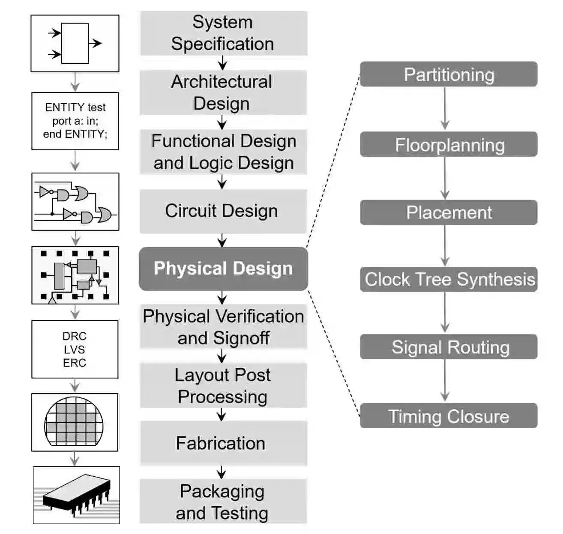

# Chapter 2: Literature Review

**Key Publications:**

* VLSI DSP education
* A Mixed-signal Analog-Digital Integrator Design
* A case study of mixed-signal integrated circuit testing: an application of current testing using the upper limit and the lower limit

**Key Resources:**

* **IEEE(**Institute of Electrical and Electronics Engineers**)**

**References :**

* [**https://ieeexplore.ieee.org/document/409304**](https://ieeexplore.ieee.org/document/409304)
* [**https://ieeexplore.ieee.org/abstract/document/6132448**](https://ieeexplore.ieee.org/abstract/document/6132448)
* [**https://ieeexplore.ieee.org/stamp/stamp.jsp?tp=&arnumber=471669**](https://ieeexplore.ieee.org/stamp/stamp.jsp?tp=&arnumber=471669)

# **Chapter 3: Strategic Analysis and Problem Definition**

## 3**.1 SWOT Analysis**

**Weaknesses**

* **Complexity**: Learning requires deep understanding across diverse domains.
* **Resource-Intensive**: Advanced tools and significant time investment needed.
* **Versatile Skillset**: Mastery of multiple signal types broadens problem-solving capabilities.
* **System Integration**: Essential for designing and optimizing modern, integrated systems

**Strengths**

**Threats**

* **Rapid Tech Changes**: Knowledge can become outdated quickly.
* **Competition**: Field is competitive due to its importance in technology.

**Opportunities**

* **High Demand**: Growing need for mixed-signal expertise in various industries.
* **Innovation**: Potential to pioneer new, efficient system architectures.

### **3.2 Project Plan - GANTT Chart**

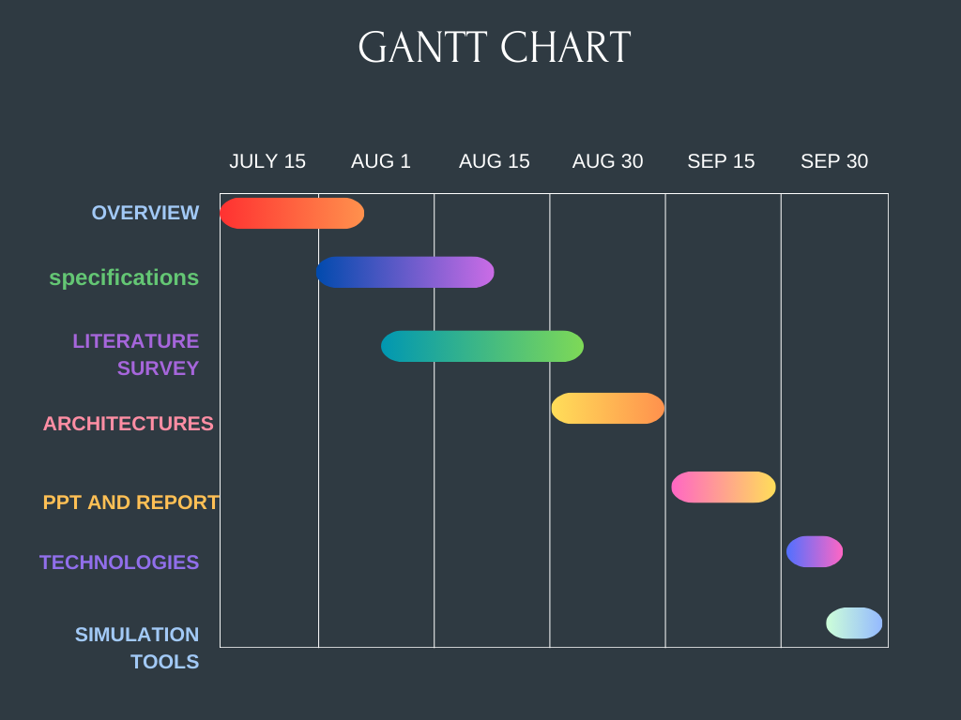

# **Chapter 4: Fundamental Blocks**

In VLSI (Very-Large-Scale Integration) design, fundamental blocks are essential elements that form the building blocks of larger systems. These blocks can be categorized into digital, analog, and mixed-signal blocks

## 4.1 Basic Components of Digital Blocks

* **Logic Gates:** Fundamental building blocks like AND, OR, NOT, NAND, NOR, XOR, and XNOR. These gates form combinational logic circuits, which are essential for performing basic operations in digital circuits.

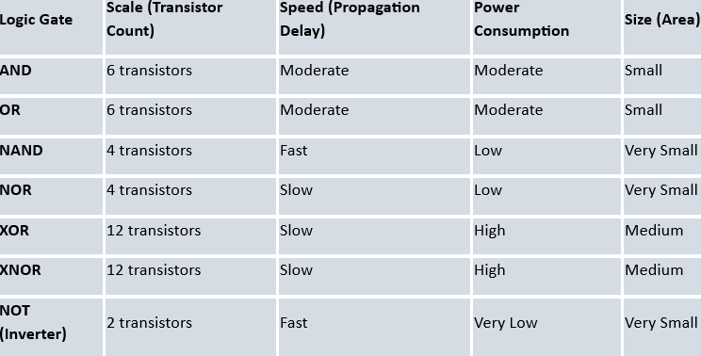

* **Flip-Flops and Latches:** These are used to store binary information (1s and 0s). They are crucial for creating sequential circuits, which rely on a clock signal to change states.

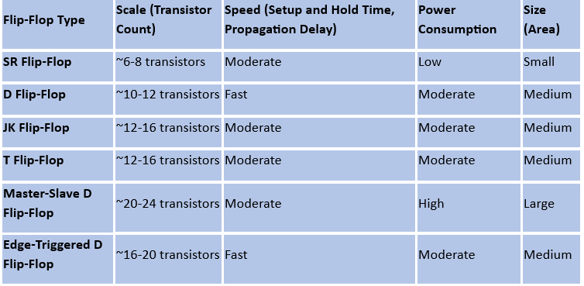

* **Registers:** Group of flip-flops used to store multiple bits of data. They are used in memory units, processors, and data transfer processes.
* **Adders and Subtractors:** Used for arithmetic operations. The most common types are half adders, full adders, and binary subtractors.
* **Multiplexers (MUX) and Demultiplexers (DEMUX):** MUX selects one input from multiple inputs, while DEMUX routes a single input to multiple outputs. They are essential in data routing and control logic.
* **Counters:** Digital blocks used to count events, typically in synchronization with a clock signal. Types include binary counters, up/down counters, and ring counters.
* **Memory Elements:** Including SRAM, DRAM, and ROM. These are used to store data and instructions in digital circuits.

## 4.2 Basic Components of Analog Blocks

* **Operational Amplifiers (Op-Amps):** Versatile analog circuits used in signal conditioning, filtering, and other analog signal processing tasks. They can perform mathematical operations like addition, subtraction, integration, and differentiation.

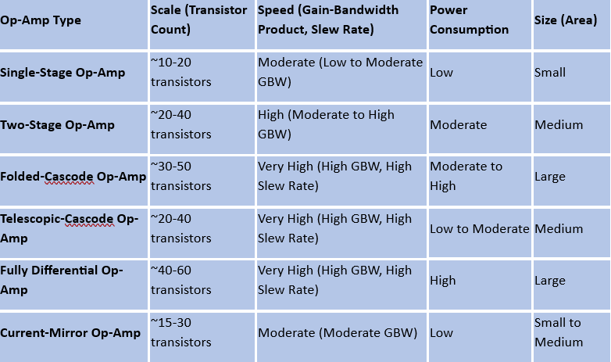

* **Analog Filters:** Circuits that allow certain frequencies to pass while blocking others. Types include low-pass, high-pass, band-pass, and band-stop filters.

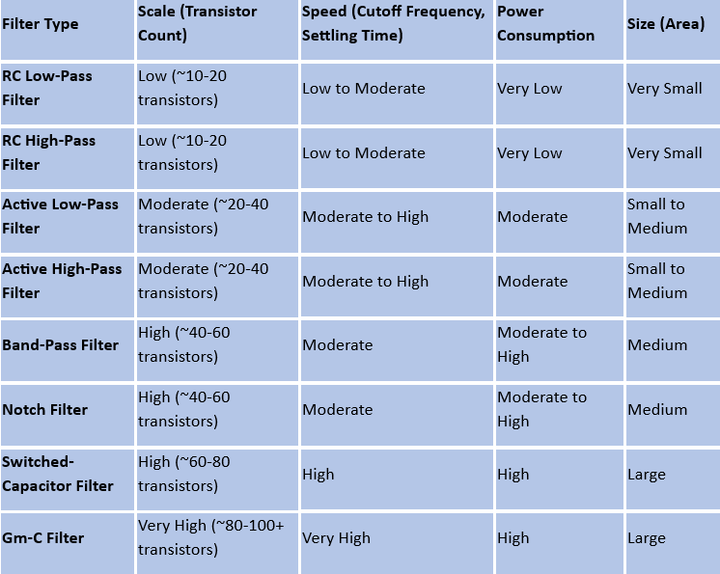

* **Oscillators:** Circuits that generate periodic waveforms, such as sine, square, or triangular waves. Common types are RC oscillators, LC oscillators, and crystal oscillators.
* **Voltage and Current Sources:** Basic components that provide stable voltage or current to other circuits. These include constant voltage sources, constant current sources, and voltage regulators.
* **Analog Multipliers:** Circuits used to multiply two analog signals. They are often used in modulation, demodulation, and frequency mixing applications.
* **Analog-to-Digital Converters (ADC):** Convert continuous analog signals into discrete digital values. ADCs are crucial in systems where analog input signals need to be processed digitally.
* **Phase-Locked Loops (PLL):** Used to synchronize an output signal's phase and frequency with a reference signal. PLLs are commonly used in communication systems, clock generation, and frequency synthesis.

#### 4.3 Basic Components of Mixed signal Blocks

* **Digital-to-Analog Converters (DAC):** Convert digital signals back into analog form. DACs are used in audio playback, video output, and various signal reconstruction tasks.
* **Data Converters (ADC/DAC):** Critical in mixed-signal systems for interfacing analog signals with digital processing units. High-speed, high-precision converters are essential for accurate data conversion.
* **Sample and Hold Circuits:** Used to sample an analog signal at a particular instance and hold its value for a specific period. These circuits are essential in ADCs to maintain signal stability during conversion.
* **Phase-Locked Loops (PLL):** In mixed-signal systems, PLLs are used for clock generation and synchronization, ensuring that the digital and analog parts of a circuit work coherently.
* **Mixed-Signal Filters:** These filters combine digital and analog filtering techniques. For instance, a digital filter might be used in conjunction with an analog anti-aliasing filter in ADC systems.
* **Power Management Circuits:** Ensure proper distribution and regulation of power across analog and digital sections. These include low-dropout regulators (LDOs), switching regulators, and power distribution networks.
* **Clock and Data Recovery (CDR) Circuits:** Essential in high-speed communication systems, these circuits recover the clock and data from a serial data stream, ensuring proper timing and signal integrity.

**These fundamental blocks are the core components in VLSI design, where digital, analog, and mixed-signal systems are integrated to create sophisticated electronic devices.**

# Chapter 5: Parameters

| **Parameter** | **Description** | **Impact** |
| --- | --- | --- |
| **Speed** | The maximum operating frequency of the circuit, often determined by the clock rate. | Affects how quickly the circuit can perform operations, impacting overall performance. |
| **Power Consumption** | The amount of power used by the circuit, including static and dynamic power. | Crucial for battery-powered devices; lower power consumption extends battery life and reduces heat. |
| **Area** | The physical size of the circuit, often measured in terms of silicon real estate. | Affects the cost of manufacturing; smaller area allows for more circuits on a single chip. |
| **Delay** | The time taken for a signal to propagate through a circuit from input to output. | Impacts timing and synchronization; lower delay is essential for high-speed circuits. |
| **Noise** | Unwanted variations in signals, including thermal, flicker, and power supply noise. | Affects signal integrity; high noise levels can lead to errors in data processing and transmission. |
| **Design Complexity** | The level of intricacy involved in designing the circuit, including the number of components. | Higher complexity can lead to increased design time, costs, and potential for errors. |
| **Power Density** | The amount of power dissipated per unit area of the chip. | Higher power density can cause thermal issues, requiring advanced cooling techniques. |
| **Yield** | The percentage of manufactured chips that meet the required specifications without defects. | Higher yield reduces costs and improves profitability; yield is influenced by design robustness and manufacturing quality. |
| **Scalability** | The ability of a design to be scaled down to smaller process nodes (e.g., from 28nm to 7nm). | Scalability is essential for keeping up with Moore’s Law and improving performance in newer technology nodes. |
| **Reliability** | The ability of a circuit to function correctly over its expected lifetime under specified conditions. | Higher reliability reduces failure rates and increases the lifetime of electronic devices. |
| **Process Variability** | Variations in manufacturing processes that can cause differences in device performance. | Affects the consistency of circuit performance; designs must be robust to process variations. |
| **Temperature Stability** | The ability of a circuit to maintain performance across a range of operating temperatures. | Important for applications in extreme environments; poor stability can lead to performance degradation. |
| **Leakage Current** | Unwanted current flow when transistors are in the off state, contributing to static power consumption. | Lower leakage current is crucial for low-power applications, especially in deep submicron technologies. |
| **Signal Integrity** | The quality of the electrical signals as they propagate through the circuit. | Poor signal integrity can lead to errors and reduced performance, especially in high-speed designs. |
| **Electromagnetic Interference (EMI)** | Unwanted electromagnetic signals that can interfere with circuit operation. | High EMI can cause malfunction in sensitive circuits and disrupt the operation of other nearby devices. |
| **Packaging** | The method used to encase the chip, affecting thermal performance, reliability, and size. | Impacts the thermal management, protection, and interconnection of the VLSI circuit with external systems. |

5.1 Parameters for Analog, Digital and Mixed signal blocks

| **Parameter** | **Analog Blocks** | **Digital Blocks** | **Mixed-Signal Blocks** |
| --- | --- | --- | --- |
| **Signal Type** | Continuous | Discrete (Binary) | Combination of Continuous and Discrete |
| **Voltage Levels** | Multiple levels, often continuous | Two levels (0 and 1) | Both continuous and discrete voltage levels |
| **Power Consumption** | Generally higher, depends on continuous signal processing | Typically lower, depends on logic transitions | Varies; combines analog's higher consumption with digital's lower |
| **Noise Sensitivity** | High; affected by thermal, flicker, and phase noise | Low; more immune to noise | Moderate; needs careful design to manage noise in both domains |
| **Speed** | Lower, limited by analog processing speeds | Higher, determined by clock frequency and logic gates | Moderate; depends on the interfacing between analog and digital blocks |
| **Area** | Larger, requires precision components like capacitors, inductors | Smaller, uses transistors and logic gates | Varies; combining analog and digital components can increase area |
| **Power Supply** | Multiple supplies for different blocks (e.g., 1.2V, 3.3V) | Single supply or multiple low-voltage supplies (e.g., 1.2V) | Multiple supplies, managing analog and digital requirements |
| **Temperature Stability** | Sensitive; performance can degrade with temperature changes | More stable across temperature variations | Requires compensation techniques for stability across domains |
| **Design Complexity** | Higher; requires precise component matching and layout | Lower; focused on logic design and timing | High; integration of analog and digital increases complexity |
| **Manufacturing Tolerance** | Tight; analog performance depends on component accuracy | Relaxed; digital performance is less sensitive to variations | Balanced; analog requires precision, while digital is more tolerant |
| **Testability** | Challenging; requires specialized techniques for measurement | Easier; can be tested using logic testers and simulation | Complex; needs both analog and digital testing approaches |
| **Key Performance Metrics** | Gain, Bandwidth, Noise Figure, Linearity, Power Consumption | Speed, Power Consumption, Area, Delay, Throughput | Signal-to-Noise Ratio (SNR), Total Harmonic Distortion (THD), Conversion Speed |
| **Design Tools** | SPICE simulations, analog-specific layout tools | HDL-based tools (e.g., VHDL, Verilog), logic simulators | Mixed-signal simulators, co-simulation environments (e.g., Cadence AMS) |
| **Applications** | Signal amplification, filtering, oscillation, sensor interfacing | Computation, data processing, control logic | ADC/DAC, communication systems, sensor integration, power management |

## 5.2 Parameters for each basic component in digital blocks

| **Parameter** | **Logic Gates** | **Combinational Circuits** | **Sequential Circuits** | **ALU (Arithmetic Logic Unit)** | **Memory Blocks** |
| --- | --- | --- | --- | --- | --- |
| **Performance** | Basic, performs simple logic operations | Intermediate, performs complex logic operations | Advanced, supports state-based operations | High, performs arithmetic and logical functions | Varies; high performance in data storage/retrieval |
| **Design Complexity** | Low, simple design with basic logic elements | Moderate, requires more gates and connections | High, involves feedback and timing considerations | High, combines multiple operations into one unit | High, involves intricate cell design and architecture |
| **Speed** | Very High, depends on the propagation delay | High, depends on the circuit depth and fan-out | Moderate to Low, limited by clock frequency | High, optimized for fast arithmetic operations | Varies, depends on access time and architecture |
| **Noise Sensitivity** | Low, typically immune to noise | Low to Moderate, depends on complexity and fan-out | Moderate, susceptible to clock noise and jitter | Moderate, noise affects arithmetic precision | High, sensitive to electrical noise in memory cells |
| **Area** | Small, requires minimal chip area | Larger, increases with circuit complexity | Large, requires additional storage elements like flip-flops | Large, integrates multiple functional units | Large, especially in high-density memory arrays |
| **Delay** | Minimal, limited to gate propagation delay | Low to Moderate, accumulates with gate levels | Moderate to High, depends on clock cycles | Moderate, delay depends on operation complexity | Varies, access time depends on type (SRAM, DRAM) |
| **Power Consumption** | Low, due to simple operation and fewer transistors | Moderate, more gates lead to higher power usage | High, due to clocking and state retention | High, due to high activity and operation density | High, particularly in dynamic memories (DRAM) |
| **Reliability** | High, simple structures are less prone to failure | High, reliability depends on gate count and interconnections | Moderate, clock-related issues can cause failures | High, critical for correct operation of arithmetic tasks | Moderate, susceptible to bit errors and data corruption |
| **Application Examples** | AND, OR, NOT gates in basic logic operations | Adders, Multiplexers, Decoders, Encoders | Counters, Registers, Flip-Flops | Microprocessor ALUs, Digital Signal Processing units | RAM, ROM, Cache memory blocks |

## 5.3 Parameters for each basic component in analog blocks

| **Parameter** | **Op-Amps** | **Analog Filters** | **Oscillators** | **Voltage & Current Sources** | **Analog Multipliers** |
| --- | --- | --- | --- | --- | --- |
| **Performance** | High gain, high input impedance, low output impedance | Selectivity, insertion loss, filter order | Frequency stability, low phase noise | Precision, stability, low output noise | Linearity, bandwidth, low distortion |
| **Design Complexity** | Moderate to high; depends on required precision and stability | Varies; higher-order filters are more complex | Moderate; depends on desired frequency accuracy | Moderate to high; requires precision components | High; involves nonlinear components and feedback |
| **Speed** | Moderate; depends on bandwidth and slew rate | Varies; higher cutoff frequency filters are faster | High; depends on frequency range | Generally low; DC or low-frequency operation | Moderate; limited by response time and bandwidth |
| **Noise** | Low noise design required for high precision | Low noise desired; varies by filter type | Low to moderate; phase noise is critical | Low noise critical, especially for voltage references | Moderate; noise impacts accuracy in signal processing |
| **Area** | Moderate; depends on the number of stages and compensation | Moderate; depends on filter order and topology | Small to moderate; depends on resonator type | Small to moderate; depends on precision requirements | Moderate; area depends on the complexity of the circuit |
| **Delay** | Minimal; primarily influenced by bandwidth | Dependent on filter type (e.g., FIR, IIR) | Low; usually negligible in steady-state operation | Negligible; primary delay in feedback regulation | Moderate; delay can affect signal processing accuracy |

## 5.4 Parameters for each basic component in mixed signal blocks

| **Parameter** | **Analog-to-Digital Converters (ADCs)** | **Digital-to-Analog Converters (DACs)** | **Phase-Locked Loops (PLLs)** | **Mixed-Signal Filters** | **Voltage References** |
| --- | --- | --- | --- | --- | --- |
| **Performance** | High accuracy, resolution, SNR, and linearity | High resolution, low distortion | High frequency stability and low jitter | High selectivity, low distortion | High stability, low temperature drift |
| **Design Complexity** | High; involves precise analog and digital integration | Moderate; less complex than ADCs | High; requires precise control of analog and digital parts | High; combines analog and digital filtering | Moderate; requires stable reference generation |
| **Speed** | Varies; high-speed ADCs can reach several Gsps | Varies; high-speed DACs up to several Gsps | High; PLLs can operate in the GHz range | Moderate; depends on filter type and application | Moderate; needs to respond quickly to load changes |
| **Noise** | Susceptible to thermal noise, quantization noise | Susceptible to noise and distortion | Sensitive to phase noise, jitter | Moderate; noise impacts overall signal quality | Low; designed to minimize output noise |
| **Area** | Large; depends on resolution and architecture | Large; depends on resolution and architecture | Moderate; compact but requires precise layout | Moderate to large; area depends on complexity | Small; typically occupies minimal area |
| **Delay** | Moderate to high; depends on conversion time and sampling rate | Low to moderate; depends on architecture | Low; fast phase locking is critical | Low to moderate; depends on filter design | Very low; needs to provide stable voltage quickly |

# Chapter 6: Implementation Tools

| **Aspect** | **Implementation Tools** |
| --- | --- |
| **Purpose** | To actually create the physical design and layout of the circuit on silicon. |
| **Stage in Design Flow** | Used in the physical design and manufacturing stages. |
| **Functionality** | Synthesize the design, place and route the components, and generate the final layout. |
| **Types of Analysis** | Physical design, layout, timing, power, and signal integrity after synthesis. |
| **Output** | Physical design files (e.g., GDSII, LEF/DEF) and implementation reports. |
| **Examples** | Synopsys Design Compiler (synthesis); Cadence Innovus, Synopsys IC Compiler (place and route); Mentor Calibre (DRC/LVS). |
| **Key Focus** | Translating the design into a manufacturable physical layout and ensuring it meets design rules. |
| **Output Verification** | Physical layout is verified against design rules and for manufacturability. |
| **Typical Users** | Physical design engineers and layout designers who are involved in translating the design into a physical form. |

## 6.1 Hardware Implementation Tools

| **Tool Type** | **Digital Systems** | **Analog Systems** | **Mixed-Signal Systems** |
| --- | --- | --- | --- |
| **Circuit Simulation** | Digital Circuit Simulators | Analog Circuit Simulators | Mixed-Signal Circuit Simulators |
|  | (e.g., ModelSim, Synopsys VCS) | (e.g., SPICE, Cadence Spectre) | (e.g., Cadence AMS, Mentor HyperLynx) |
| **Functional Simulation** | Functional Verification Tools | Functional Verification Tools | Mixed-Signal Functional Verification Tools |
|  | (e.g., ModelSim, Xilinx Vivado Simulator) | (e.g., Cadence Incisive, Mentor Graphics) | (e.g., Cadence AMS, Mentor Graphics) |
| **Timing Simulation** | Timing Analysis Tools | Timing Analysis Tools | Mixed-Signal Timing Analysis Tools |
|  | (e.g., Synopsys PrimeTime, Cadence Tempus) | (e.g., Cadence Spectre, Mentor Graphics) | (e.g., Cadence AMS, Synopsys PrimeTime) |
| **Behavioral Simulation** | Behavioral Simulation Tools | Behavioral Simulation Tools | Mixed-Signal Behavioral Simulation Tools |
|  | (e.g., ModelSim, Synopsys VCS) | (e.g., MATLAB/Simulink, Cadence Simulink) | (e.g., MATLAB/Simulink, Cadence AMS) |
| **Post-Layout Simulation** | Post-Layout Extraction Tools | Post-Layout Extraction Tools | Mixed-Signal Post-Layout Simulation Tools |
|  | (e.g., Synopsys IC Compiler, Cadence Innovus) | (e.g., Cadence Assura, Mentor Calibre) | (e.g., Cadence Virtuoso, Mentor Calibre) |
| **Signal Integrity Simulation** | Signal Integrity Simulation Tools | Not typically used for analog circuits | Mixed-Signal Signal Integrity Simulation Tools |
|  | (e.g., Ansys SIwave, Cadence Sigrity) |  | (e.g., Ansys SIwave, Cadence Sigrity) |
| **Power Analysis** | Power Analysis Tools | Power Analysis Tools | Mixed-Signal Power Analysis Tools |
|  | (e.g., Synopsys Power Compiler, Cadence Voltus) | (e.g., Cadence Voltus, Mentor Graphics) | (e.g., Cadence Voltus, Mentor Graphics) |
| **Temperature Simulation** | Temperature Effect Simulation Tools | Temperature Effect Simulation Tools | Mixed-Signal Temperature Simulation Tools |
|  | (e.g., Synopsys HSPICE, Cadence Spectre) | (e.g., Cadence Spectre, Mentor Graphics) | (e.g., Cadence Virtuoso, Mentor Graphics) |

### 6.2 Software Implementation Tools

| **Tool Category** | **Tool Name** | **Description** | **Typical Use** |
| --- | --- | --- | --- |
| **Synthesis** | **Synopsys Design Compiler** | Converts HDL (VHDL/Verilog) code into gate-level netlists. | RTL synthesis and optimization |
|  | **Cadence Genus** | High-performance RTL synthesis tool with support for advanced design constraints. | RTL synthesis and design optimization |
|  | **Mentor Precision RTL** | RTL synthesis tool focused on design convergence and quality. | RTL synthesis and verification |
| **Place and Route** | **Cadence Innovus** | Provides place and route capabilities, including timing and power optimization. | Physical design and layout |
|  | **Synopsys IC Compiler II** | Offers advanced place and route capabilities with high performance. | Physical design and layout |
|  | **Mentor Calibre** | Provides DRC (Design Rule Checking) and LVS (Layout vs. Schematic) tools. | Verification and validation of layout |
| **Layout** | **Cadence Virtuoso** | Used for custom IC design with analog, mixed-signal, and RF capabilities. | Analog and mixed-signal design |
|  | **Mentor Tanner** | Tools for analog and mixed-signal design with layout and schematic capture. | Custom IC design and layout |
|  | **Synopsys Custom Designer** | Supports custom layout design for analog and mixed-signal circuits. | Custom analog and mixed-signal layout |
| **Timing Analysis** | **Synopsys PrimeTime** | Provides static timing analysis to ensure design meets timing constraints. | Timing verification and optimization |
|  | **Cadence Tempus** | Offers advanced static timing analysis and optimization capabilities. | Timing verification and optimization |
|  | **Mentor TimingDesigner** | Timing analysis and optimization tool with support for complex designs. | Timing verification and optimization |
| **Power Analysis** | **Synopsys Power Compiler** | Tool for power optimization during synthesis and implementation. | Power optimization and analysis |
|  | **Cadence Voltus** | Provides power analysis and signoff with detailed power integrity checks. | Power integrity and analysis |
|  | **Mentor PowerPro** | Tool for power analysis and optimization focusing on dynamic and static power. | Power analysis and optimization |
| **Verification** | **Cadence Xcelium** | Supports functional simulation and verification of digital designs. | Functional verification and simulation |
|  | **Mentor Questa** | Offers simulation and verification tools for digital designs. | Functional verification and simulation |
|  | **Synopsys VCS** | High-performance digital simulation tool for functional verification. | Functional verification and simulation |
| **Design Rule Checking (DRC)** | **Cadence Assura** | Provides comprehensive design rule checking for physical verification. | Layout verification and DRC |
|  | **Mentor Calibre** | Offers DRC and LVS for ensuring design compliance with manufacturing rules. | Layout verification and DRC |
|  | **Synopsys IC Validator** | DRC tool that checks design against manufacturing process rules. | Layout verification and DRC |

# Chapter 7: Simulation Tools

| **Aspect** | **Simulation Tools** |
| --- | --- |
| **Purpose** | To model and analyze the behaviour and performance of a design before it is physically built. |
| **Stage in Design Flow** | Used primarily in the design and verification stages. |
| **Functionality** | Simulate circuit behaviour, verify functionality, timing, and signal integrity. |
| **Types of Analysis** | Functional, timing, power, signal integrity, thermal, etc. |
| **Output** | Simulation results (e.g., waveforms, timing diagrams, signal voltages). |
| **Examples** | ModelSim, Cadence Xcelium (digital); SPICE, Cadence Spectre (analog); Cadence AMS (mixed-signal). |
| **Key Focus** | Verifying that the design behaves as expected under various conditions. |
| **Output Verification** | Results are checked against specifications to ensure correctness. |
| **Typical Users** | Design engineers and verification engineers who need to check design correctness. |

### 7.1 Hardware Simulation Tools

| **Tool Type** | **Tool Name** | **Description** | **Primary Use** |
| --- | --- | --- | --- |
| **Digital Simulation** | ModelSim | A widely used digital simulator for RTL and gate-level simulation. | Digital circuit verification and debugging. |
|  | Synopsys VCS | High-performance digital simulation tool with advanced debugging capabilities. | Digital design verification and functional simulation. |
|  | Xilinx Vivado Simulator | Simulator integrated with Xilinx FPGA design tools for digital designs. | FPGA design and verification. |
| **Analog Simulation** | SPICE | A standard analog circuit simulator used for detailed analog and mixed-signal simulation. | Analog circuit analysis and verification. |
|  | Cadence Spectre | Advanced SPICE-based simulator for accurate analog and RF circuit simulation. | High-precision analog and RF circuit simulation. |
|  | Mentor Graphics Eldo | Analog simulator known for high-speed and high-performance simulations. | Analog and mixed-signal simulation. |
| **Mixed-Signal Simulation** | Cadence AMS | Provides comprehensive support for analog, digital, and mixed-signal simulation. | Mixed-signal circuit simulation and verification. |
|  | Mentor HyperLynx | Tool for signal integrity and mixed-signal simulation, focusing on high-speed designs. | Mixed-signal and high-speed design analysis. |
| **Functional Simulation** | Cadence Incisive | Offers comprehensive functional verification with support for various design languages. | Functional verification of digital designs. |
|  | Synopsys ZeBu | Emulation tool for fast functional verification of complex designs. | High-speed functional simulation and verification. |
| **Timing Simulation** | Synopsys PrimeTime | Provides detailed timing analysis and optimization for digital designs. | Static timing analysis and optimization. |
|  | Cadence Tempus | High-performance timing analysis tool with advanced capabilities. | Timing analysis and sign-off. |
| **Power Simulation** | Synopsys Power Compiler | Tool for power analysis and optimization in digital designs. | Power estimation and optimization. |
|  | Cadence Voltus | Power integrity and sign-off tool with advanced power analysis capabilities. | Power analysis and management. |
| **Signal Integrity Simulation** | Ansys SIwave | Provides simulation and analysis for signal integrity and EMI/EMC in PCBs and ICs. | Signal integrity and electromagnetic analysis. |
|  | Cadence Sigrity | Signal integrity simulation tool for high-speed designs and PCBs. | Signal integrity and design analysis. |

### 7.2 Software Simulation Tools

| **Tool Type** | **Tool Name** | **Description** | **Category** |
| --- | --- | --- | --- |
| **Digital Simulation** | ModelSim | Digital logic simulator for verifying RTL designs and timing. | Digital Simulation |
|  | Synopsys VCS | High-performance digital simulator for RTL and gate-level designs. | Digital Simulation |
|  | Xilinx Vivado Simulator | Simulation tool integrated with Vivado for FPGA designs. | Digital Simulation |
| **Analog Simulation** | SPICE | General-purpose analog simulator for circuit analysis. | Analog Simulation |
|  | Cadence Spectre | Analog and mixed-signal circuit simulator with advanced modeling. | Analog Simulation |
|  | Mentor Graphics Eldo | Analog circuit simulator for precise modeling and analysis. | Analog Simulation |
| **Mixed-Signal Simulation** | Cadence AMS (Analog Mixed-Signal) | Simulation tool for both analog and digital circuit analysis. | Mixed-Signal Simulation |
|  | Mentor Graphics HyperLynx | Provides mixed-signal simulation with signal integrity analysis. | Mixed-Signal Simulation |
|  | Synopsys HSPICE | High-performance simulator for both analog and mixed-signal circuits. | Mixed-Signal Simulation |
| **Timing Analysis** | Synopsys PrimeTime | Static timing analysis tool for verifying timing constraints. | Timing Analysis |
|  | Cadence Tempus | High-performance static timing analysis tool. | Timing Analysis |
| **Functional Verification** | Cadence Incisive | Comprehensive tool for functional verification, including simulation and formal verification. | Functional Verification |
|  | Synopsys Verilog-XL | Functional verification tool for simulation of Verilog designs. | Functional Verification |
| **Power Analysis** | Synopsys Power Compiler | Tool for power analysis and optimization in digital designs. | Power Analysis |
|  | Cadence Voltus | Power analysis tool for both static and dynamic power analysis. | Power Analysis |
| **Signal Integrity Analysis** | Ansys SIwave | Tool for signal integrity and electromagnetic analysis. | Signal Integrity Analysis |
|  | Cadence Sigrity | Provides signal integrity analysis for high-speed designs. | Signal Integrity Analysis |

# Chapter 8 : Comparison

### 8.1 Comparison Between Analog, Digital, and Mixed Signal Systems

| **Aspect** | **Analog Systems** | **Digital Systems** | **Mixed-Signal Systems** |
| --- | --- | --- | --- |
| **Signal Type** | Continuous signals | Discrete signals (binary) | Combination of continuous and discrete signals |
| **Design Approach** | Focus on continuous signal processing with precise analog components. | Focus on logic gates and sequential circuits with discrete operations. | Integration of both analog and digital components, requiring a combination of design methodologies. |
| **Performance Metrics** | Gain, bandwidth, noise figure, linearity | Speed, power consumption, area, timing | Signal-to-noise ratio (SNR), total harmonic distortion (THD), conversion speed |
| **Power Consumption** | Generally higher; depends on continuous signal processing. | Typically lower; depends on switching activity. | Varies; combines analog’s higher consumption with digital’s lower consumption. |
| **Speed** | Generally lower; limited by analog processing speeds. | Generally higher; limited by clock frequency and logic gates. | Moderate; depends on the interface between analog and digital components. |
| **Area** | Larger; requires space for analog components like capacitors and inductors. | Smaller; uses compact transistors and logic gates. | Varies; combining analog and digital components can increase area. |
| **Noise Sensitivity** | High; affected by thermal, flicker, and phase noise. | Low; more immune to noise due to discrete nature. | Moderate; requires careful design to manage noise in both domains. |
| **Design Complexity** | High; requires precise component matching and layout. | Lower; focused on logic design and timing. | High; integration of analog and digital components increases complexity. |
| **Testing and Verification** | Challenging; specialized techniques for measurement and verification. | Easier; can use standard logic testers and simulation. | Complex; needs both analog and digital testing approaches. |
| **Simulation Tools** | SPICE, Cadence Spectre, Mentor Graphics Eldo. | ModelSim, Synopsys VCS, Xilinx Vivado. | Cadence AMS, Mentor HyperLynx. |
| **Implementation Tools** | Cadence Virtuoso, Mentor Calibre, Analog Layout Tools. | Cadence Innovus, Synopsys IC Compiler, Digital Layout Tools. | Cadence Virtuoso for layout, Synopsys IC Compiler for digital integration. |
| **Typical Applications** | Analog filters, amplifiers, oscillators, sensors. | Microprocessors, memory, digital communication systems. | ADCs/DACs, communication systems, sensor interfaces, power management. |

### 8.2 Advantages and Disadvantages

**Advantages**:

| **System Type** | **Advantages** |
| --- | --- |
| **Analog Systems** | - **High Resolution**: Analog systems can process signals with very fine resolution, useful for precise measurements and high-fidelity applications.  - **Continuous Signals**: Capable of handling continuous signals and maintaining signal quality with minimal distortion.  - **Real-Time Processing**: Effective for real-time processing tasks where continuous signal processing is required, such as audio and RF systems.  - **Low Power for Simple Tasks**: In some cases, analog circuits can be more power-efficient for specific tasks compared to digital circuits. |
| **Digital Systems** | - **Noise Immunity**: Digital systems are less affected by noise and signal degradation, which makes them reliable for data transmission and processing.  - **Ease of Design and Debugging**: Digital design tools and methodologies simplify design and debugging processes, with well-established verification techniques.  - **Scalability**: Digital systems can be scaled down to smaller technology nodes, allowing for high-density integration and better performance.  - **Flexibility**: Digital systems can be easily reprogrammed or modified, offering high versatility for various applications.  - **Power Efficiency for Complex Operations**: Digital circuits often consume less power for complex calculations compared to analog systems. |
| **Mixed-Signal Systems** | - **Versatility**: Combines the best features of both analog and digital systems, allowing for a wide range of applications including analog-to-digital conversion and signal processing.  - **Integration**: Allows integration of analog and digital functions on a single chip, reducing the need for external components and minimizing system size and cost.  - **Improved Performance**: Enhances system performance by leveraging analog precision for signal acquisition and digital processing for computation and control.  - **Cost and Space Efficiency**: Reduces overall system cost and board space by combining both analog and digital functions into one chip.  - **Better System Coordination**: Facilitates more seamless interaction between analog and digital domains, improving system-level coordination and efficiency. |

**Disadvantages:**

| **System Type** | **Disadvantages** |
| --- | --- |
| **Analog Systems** | - **Noise Sensitivity**: Analog circuits are more susceptible to noise and interference, affecting performance and accuracy. - **Design Complexity**: Requires precise component matching and careful layout. - **Temperature Variability**: Analog performance can vary with temperature changes. - **Nonlinearity**: Analog components can exhibit nonlinear behavior, complicating design. - **Scaling Limitations**: Analog circuits do not scale as effectively with technology advancements as digital circuits. |
| **Digital Systems** | - **Power Consumption**: Digital circuits can consume significant power, especially at high speeds. - **Area**: High-density digital designs can occupy a large area on the chip. - **Design Complexity**: Large digital systems can be complex to design, particularly with advanced features. - **Speed Limitations**: Performance is limited by clock speed and propagation delays. - **Testing Challenges**: Ensuring correct functionality and timing can be difficult, requiring extensive testing and verification. |
| **Mixed-Signal Systems** | - **Design Complexity**: Integrating both analog and digital components increases design complexity and challenges. - **Signal Integrity Issues**: Managing signal integrity across analog and digital boundaries can be difficult. - **Power Management**: Mixed-signal systems often require careful power management due to differing power needs of analog and digital components. - **Layout Challenges**: Physical layout must address both analog and digital requirements, complicating the design. - **Cost**: Mixed-signal designs can be more expensive to develop and manufacture due to the need for specialized design tools and processes. |

# Chapter 9: Technologies

### 91 Technologies in Analog, Digital and Mixed signal systems

1. Analog Systems Technologies

Analog systems in VLSI require precise control over voltages, currents, and signal integrity. The technologies used for analog VLSI design focus on achieving high accuracy, low noise, and stability.

* CMOS (Complementary Metal-Oxide-Semiconductor):
  + Widely used for low-power analog circuits.
  + Offers high integration density and good matching properties.
  + Commonly used in amplifiers, filters, and ADCs.

**LOGIC GATES PARAMETERS**

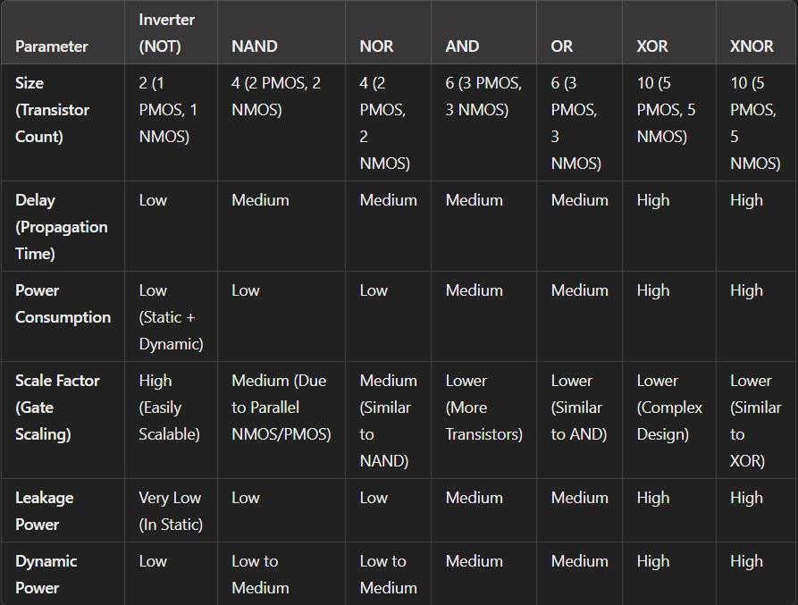

* Bipolar Junction Transistor (BJT):
  + Provides high-speed operation and better current handling than CMOS.
  + Used in high-frequency and high-precision analog circuits.
  + Typically seen in analog front-ends, RF circuits, and precision amplifiers.
* BiCMOS (Bipolar-CMOS):
  + Combines the benefits of CMOS (low power) and BJT (high speed).
  + Used in analog circuits that require both high performance and low power, such as RF circuits and ADCs.
* SOI (Silicon on Insulator):
  + Reduces parasitic capacitance, improving speed and reducing noise.
  + Used in high-speed analog circuits, especially in RF and millimeter-wave applications.
* GaAs (Gallium Arsenide):
  + Offers high electron mobility, making it suitable for high-frequency analog circuits.
  + Used in RF amplifiers, oscillators, and high-speed ADCs.

2. Digital Systems Technologies

Digital VLSI design focuses on the integration of large numbers of logic gates, processors, and memory on a single chip. The primary goal is to achieve high performance, low power consumption, and scalability.

* CMOS (Complementary Metal-Oxide-Semiconductor):
  + The most common technology for digital VLSI due to its low power consumption and high integration density.
  + Used in microprocessors, memory, and digital signal processing (DSP) circuits.
* FinFET (Fin Field-Effect Transistor):
  + A type of 3D transistor that offers improved control over channel behavior, reducing leakage and improving performance.
  + Used in advanced digital designs, particularly at sub-10nm technology nodes.
* SOI (Silicon on Insulator):
  + Reduces parasitic capacitance and leakage, leading to better performance and lower power.
  + Used in high-performance digital circuits, particularly in low-power applications.
* FD-SOI (Fully Depleted Silicon on Insulator):
  + Offers lower power consumption and higher performance than traditional bulk CMOS.
  + Used in ultra-low-power and high-performance digital circuits.
* GaN (Gallium Nitride):
  + Provides high efficiency and power handling, though less common in digital VLSI.
  + Used in specialized high-frequency digital circuits.

3. Mixed-Signal Systems Technologies

Mixed-signal VLSI design involves the integration of both analog and digital circuits on a single chip, requiring technologies that support the coexistence and interaction of these two domains.

* CMOS (Complementary Metal-Oxide-Semiconductor):
  + Dominant in mixed-signal design due to its versatility in handling both analog and digital functions.
  + Used in integrated circuits like ADCs, DACs, PLLs, and SoCs.
* BiCMOS (Bipolar-CMOS):
  + Combines the advantages of bipolar transistors for analog performance and CMOS for digital logic.
  + Used in high-performance mixed-signal circuits, including RF transceivers and high-speed ADCs/DACs.
* SOI (Silicon on Insulator):
  + Reduces noise coupling between analog and digital sections, improving performance.
  + Used in mixed-signal circuits where isolation and signal integrity are critical.
* FD-SOI (Fully Depleted Silicon on Insulator):
  + Provides low power and high performance for mixed-signal designs.
  + Ideal for RF circuits, ADCs, and other mixed-signal blocks where power efficiency is crucial.
* HV-CMOS (High-Voltage CMOS):
  + Used for mixed-signal circuits requiring high-voltage operation, such as power management ICs and display drivers.
  + Offers the ability to handle higher voltages while maintaining compatibility with standard CMOS processes.
* SiGe (Silicon-Germanium):
  + Enhances the speed and performance of mixed-signal circuits, particularly at high frequencies.
  + Used in RF transceivers, high-speed ADCs/DACs, and millimeter-wave circuits.

# Chapter 10: Architectures

### 10.1 Existing architectures using different technologies:

**CMOS technology: [invertor]**

**SCHEMATIC DAIGRAM :**

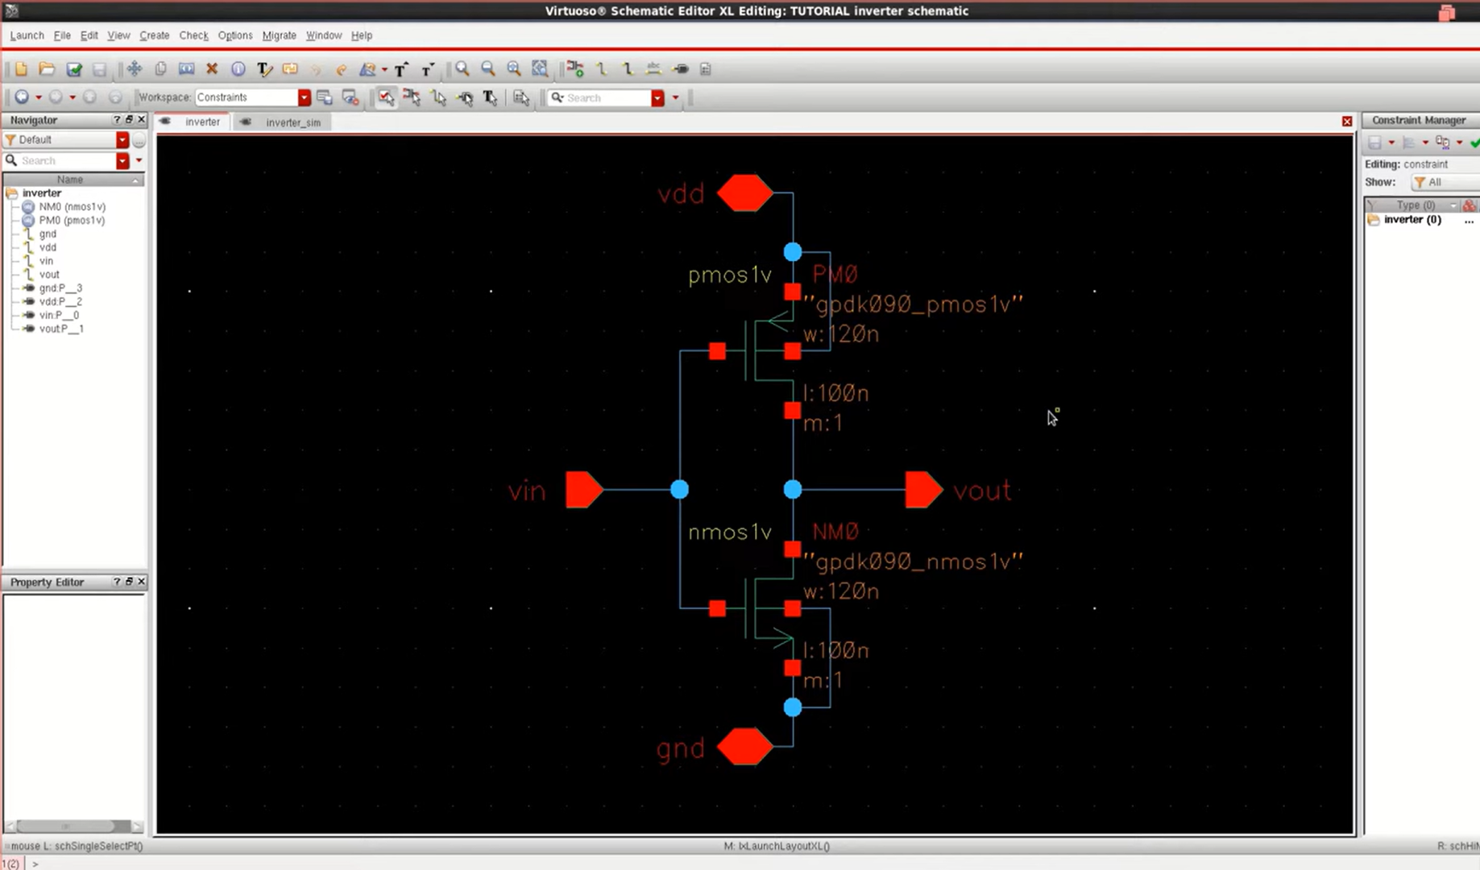

**TRANSIENT ANALYSIS:**

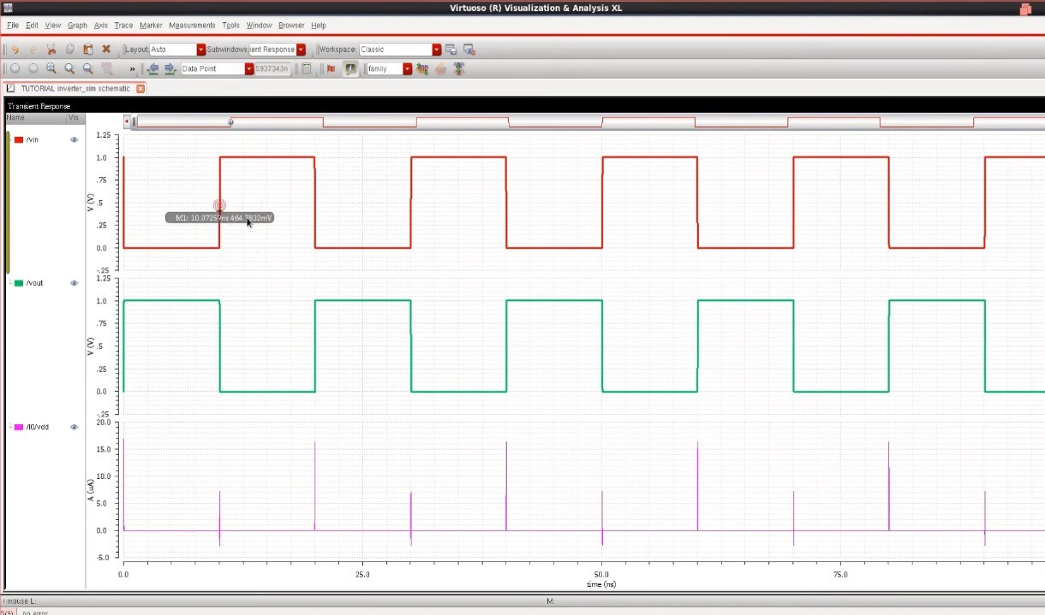

**CMOS Technology: [AND GATE]**

SCHEMATIC DAIGRAM:

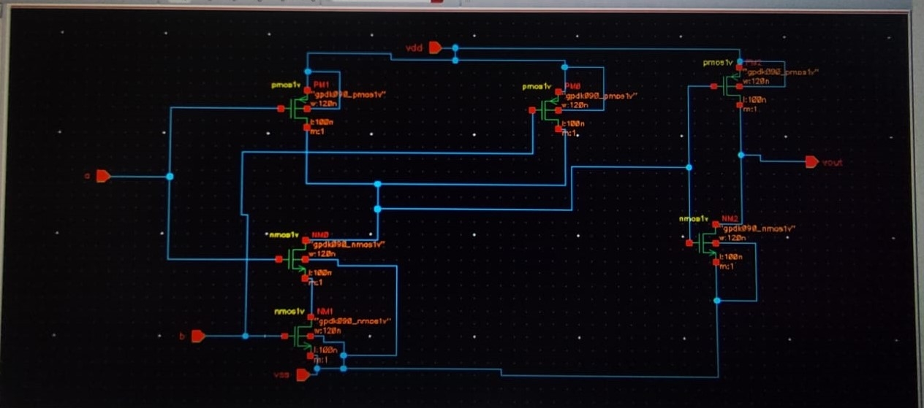

TRANSIENT ANALYSIS:

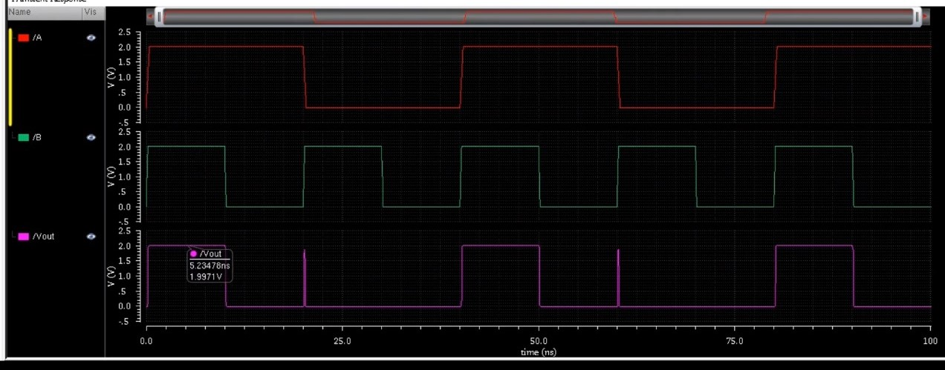

**CMOS Technology: [OR GATE]:**

SCHEMATIC DAIGRAM:

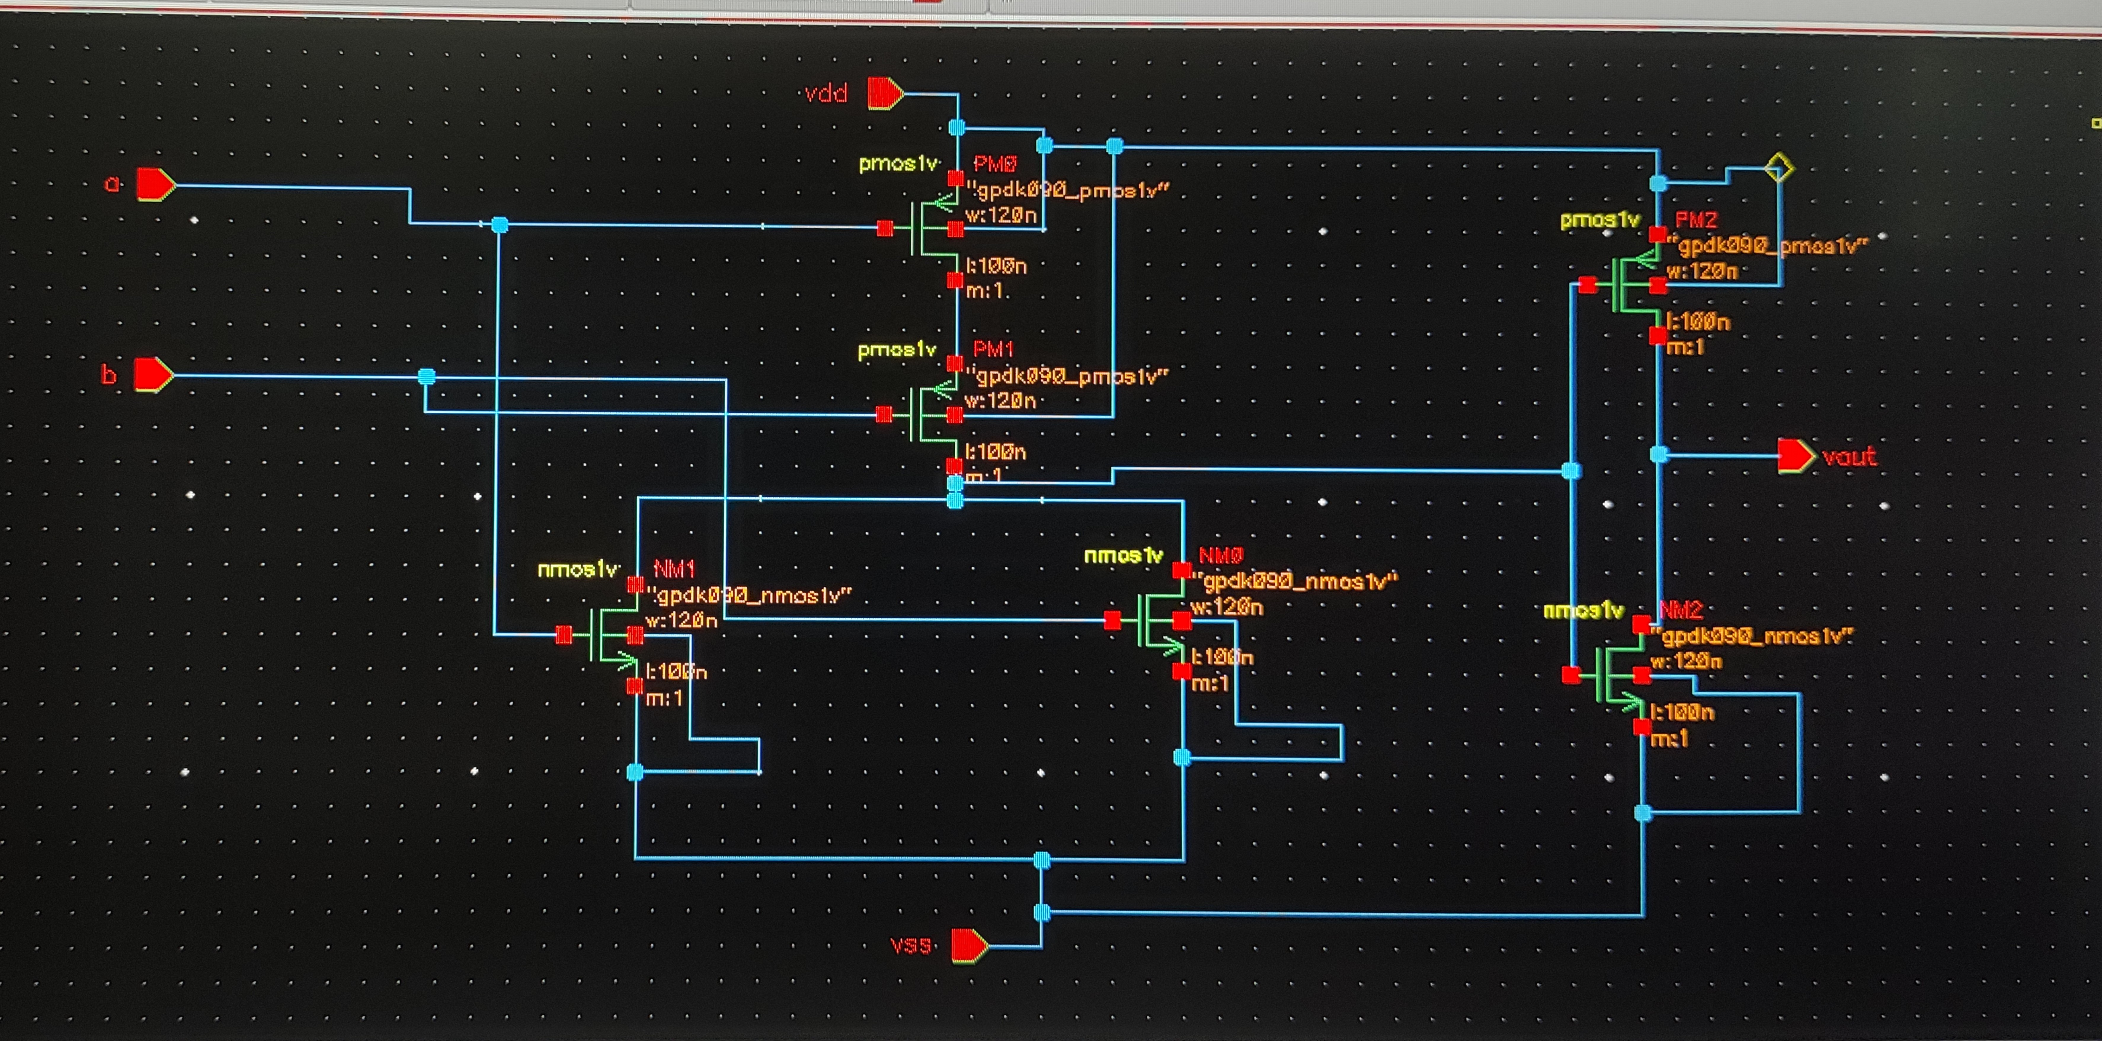

TRANSIENT ANALYSIS:

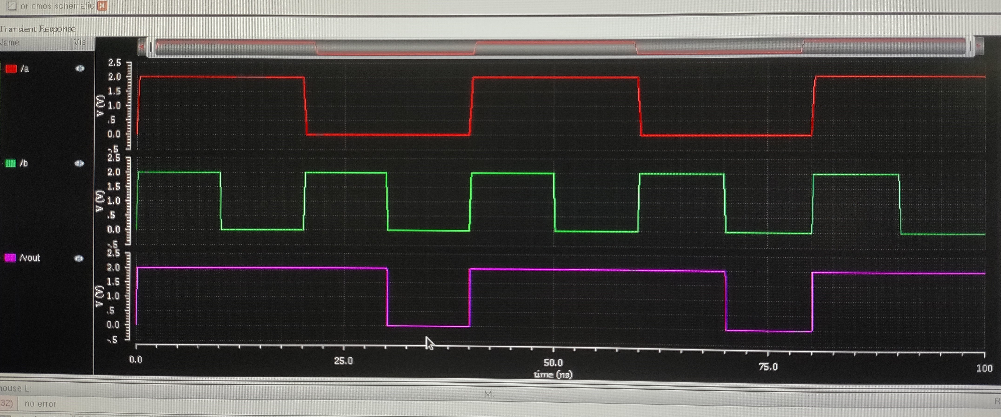

**CMOS Technology: [NAND GATE-active high]:**

SCHEMATIC DAIGRAM:

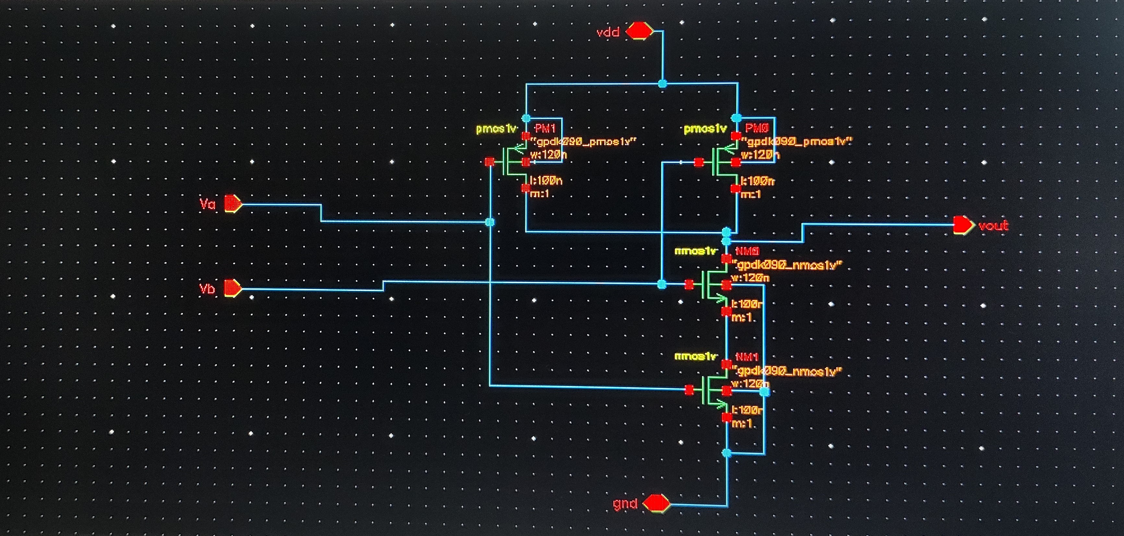

TRANSIENT ANALYSIS:

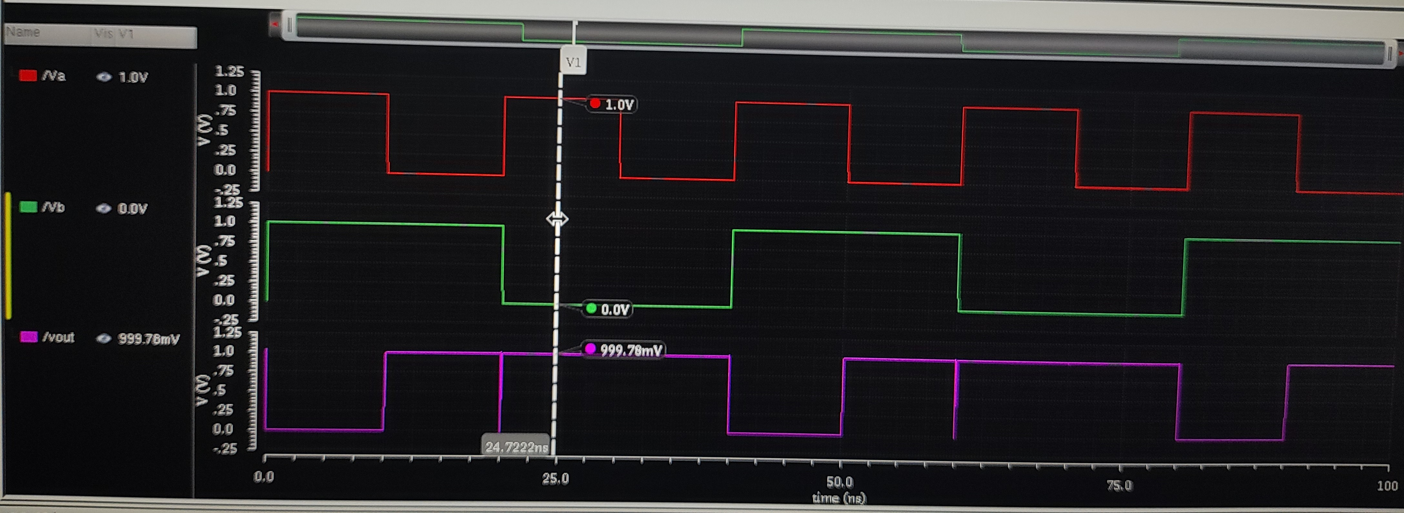

**CMOS Technology: [NOR GATE]:**

SCHEMATIC DAIGRAM:

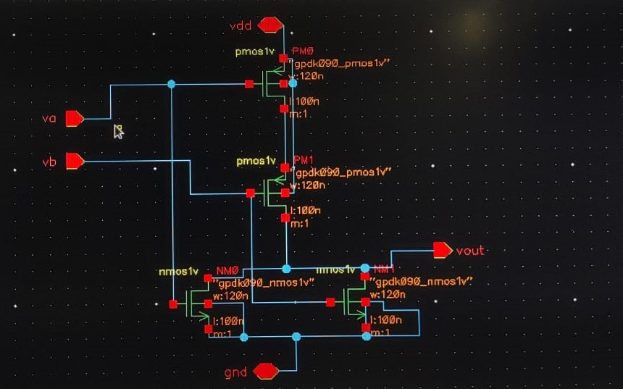

TRANSIENT ANALYSIS:

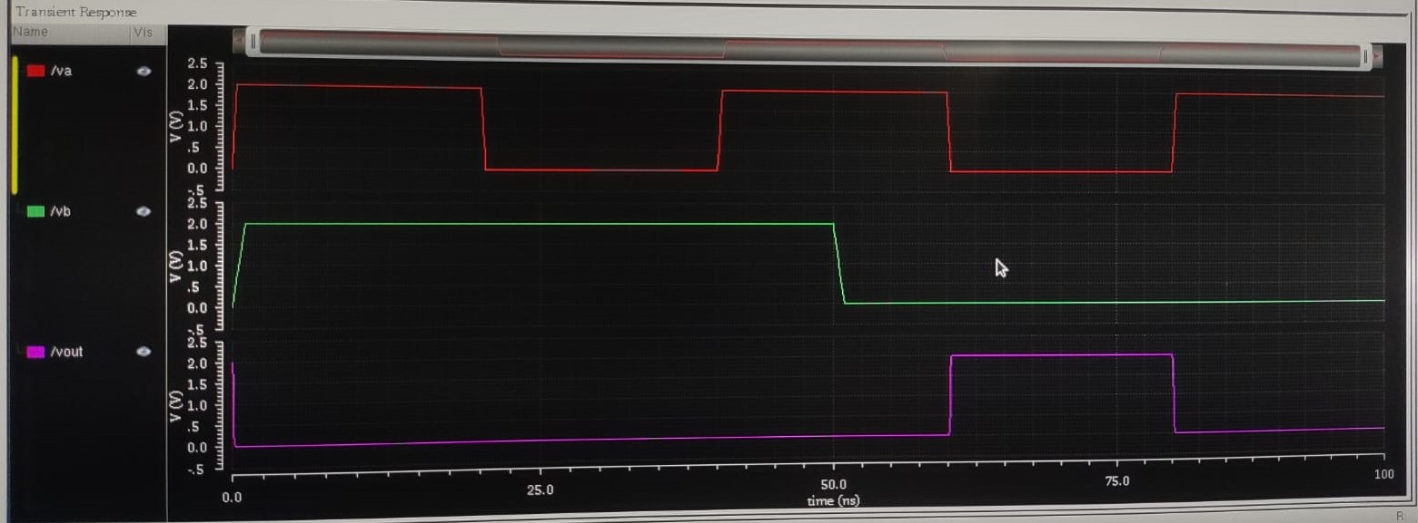

**CMOS Technology: [EX-OR GATE]:**

SCHEMATIC DAIGRAM:

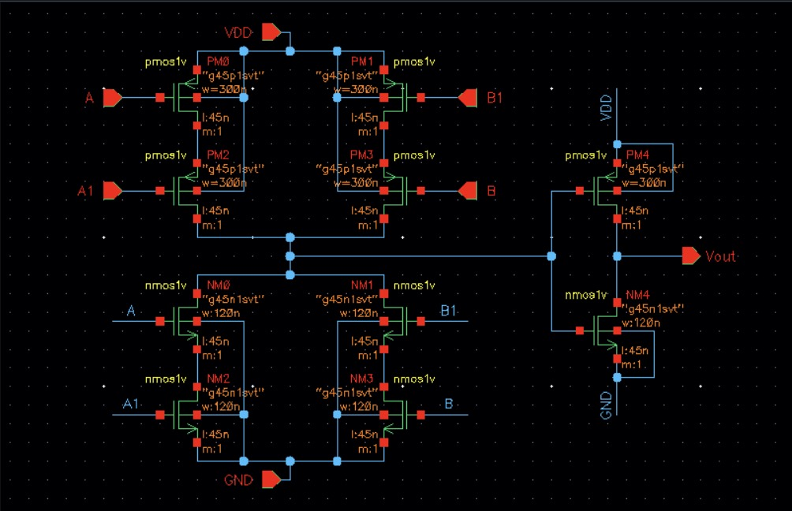

TRANSIENT ANALYSIS:

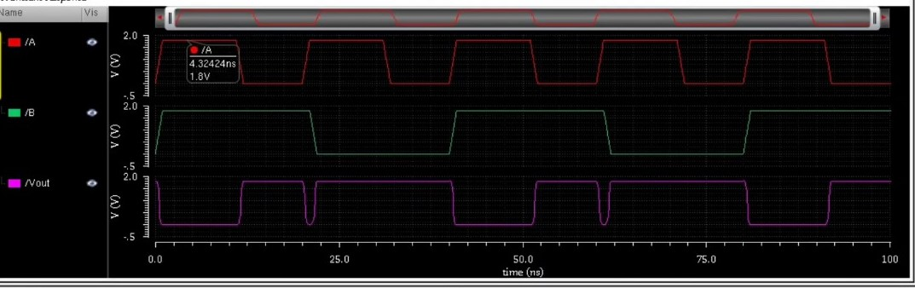

**CMOS Technology: [EX-NOR GATE]:**

SCHEMATIC DAIGRAM:

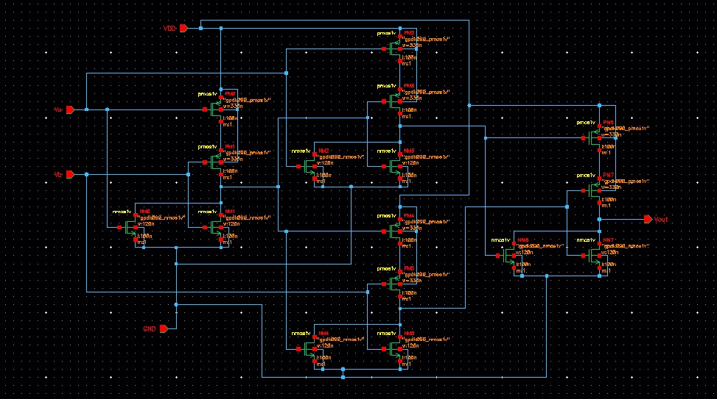

TRANSIENT ANALYSIS:

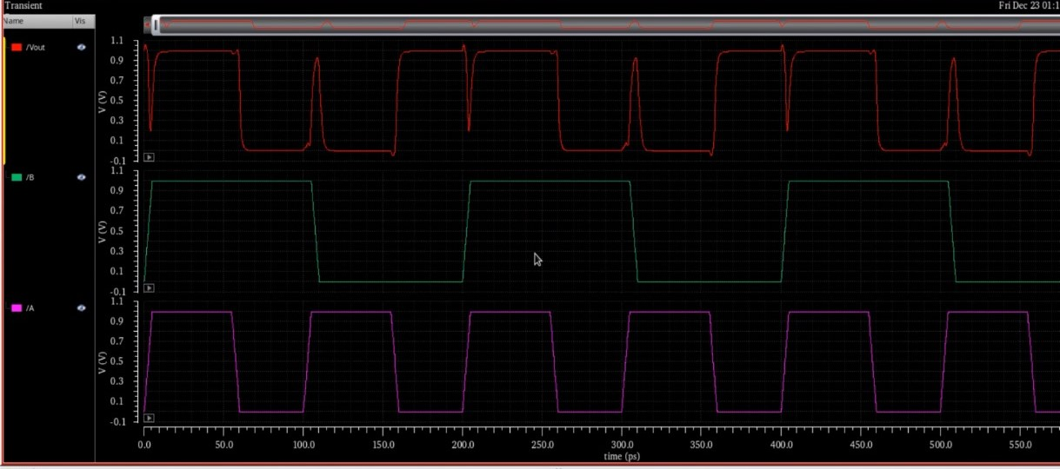

**Result:**

|  |  |  |  |  |
| --- | --- | --- | --- | --- |
| Gates/parameters | Dynamic(mw) | Static(nw) | Delay (ps) | Size (nm) |
| AND | 16.2 | 27 | 225 | 180 |
| OR | 14.2 | 27 | 223 | 180 |
| NAND | 16.9 | 27 | 225 | 180 |
| NOR | 14.9 | 27 | 225 | 180 |
| EX-OR | 24.3 | 36 | 350 | 180 |
| EX-NOR | 24.3 | 45 | 425 | 180 |

# Chapter 11: Conclusion

In conclusion, the study of digital, analog, and mixed-signal systems across different architectures reveals the strengths and limitations of each approach in various applications. Digital systems offer precision and programmability, while analog systems excel in real-time processing. Mixed-signal systems combine the best of both worlds, providing a balanced solution for complex, real-world challenges.

# Chapter 12: Future Work

* **First Implementation:**  
  The first implementation will involve creating prototypes to test the practicality and performance of the new architectures and tools in real-world scenarios.
* **Evaluation and Validation:**  
  Future efforts will include rigorous evaluation and validation of the implemented systems to ensure they meet performance standards and reliability in various applications.

# References

* <https://r.search.yahoo.com/_ylt=AwrKASg_2BdnKgIAt2G7HAx.;_ylu=Y29sbwNzZzMEcG9zAzEEdnRpZAMEc2VjA3Ny/RV=2/RE=1730825535/RO=10/RU=https%3a%2f%2fcourses.grainger.illinois.edu%2fECE205%2ffa2021%2fnotes%2fLecture19.pdf/RK=2/RS=DZDf3EKczwPh72eqUU.WEhXWVAI->
* <https://www.scribd.com/document/271029001/Tutorial-on-Cadence-Virtuoso-IISC>